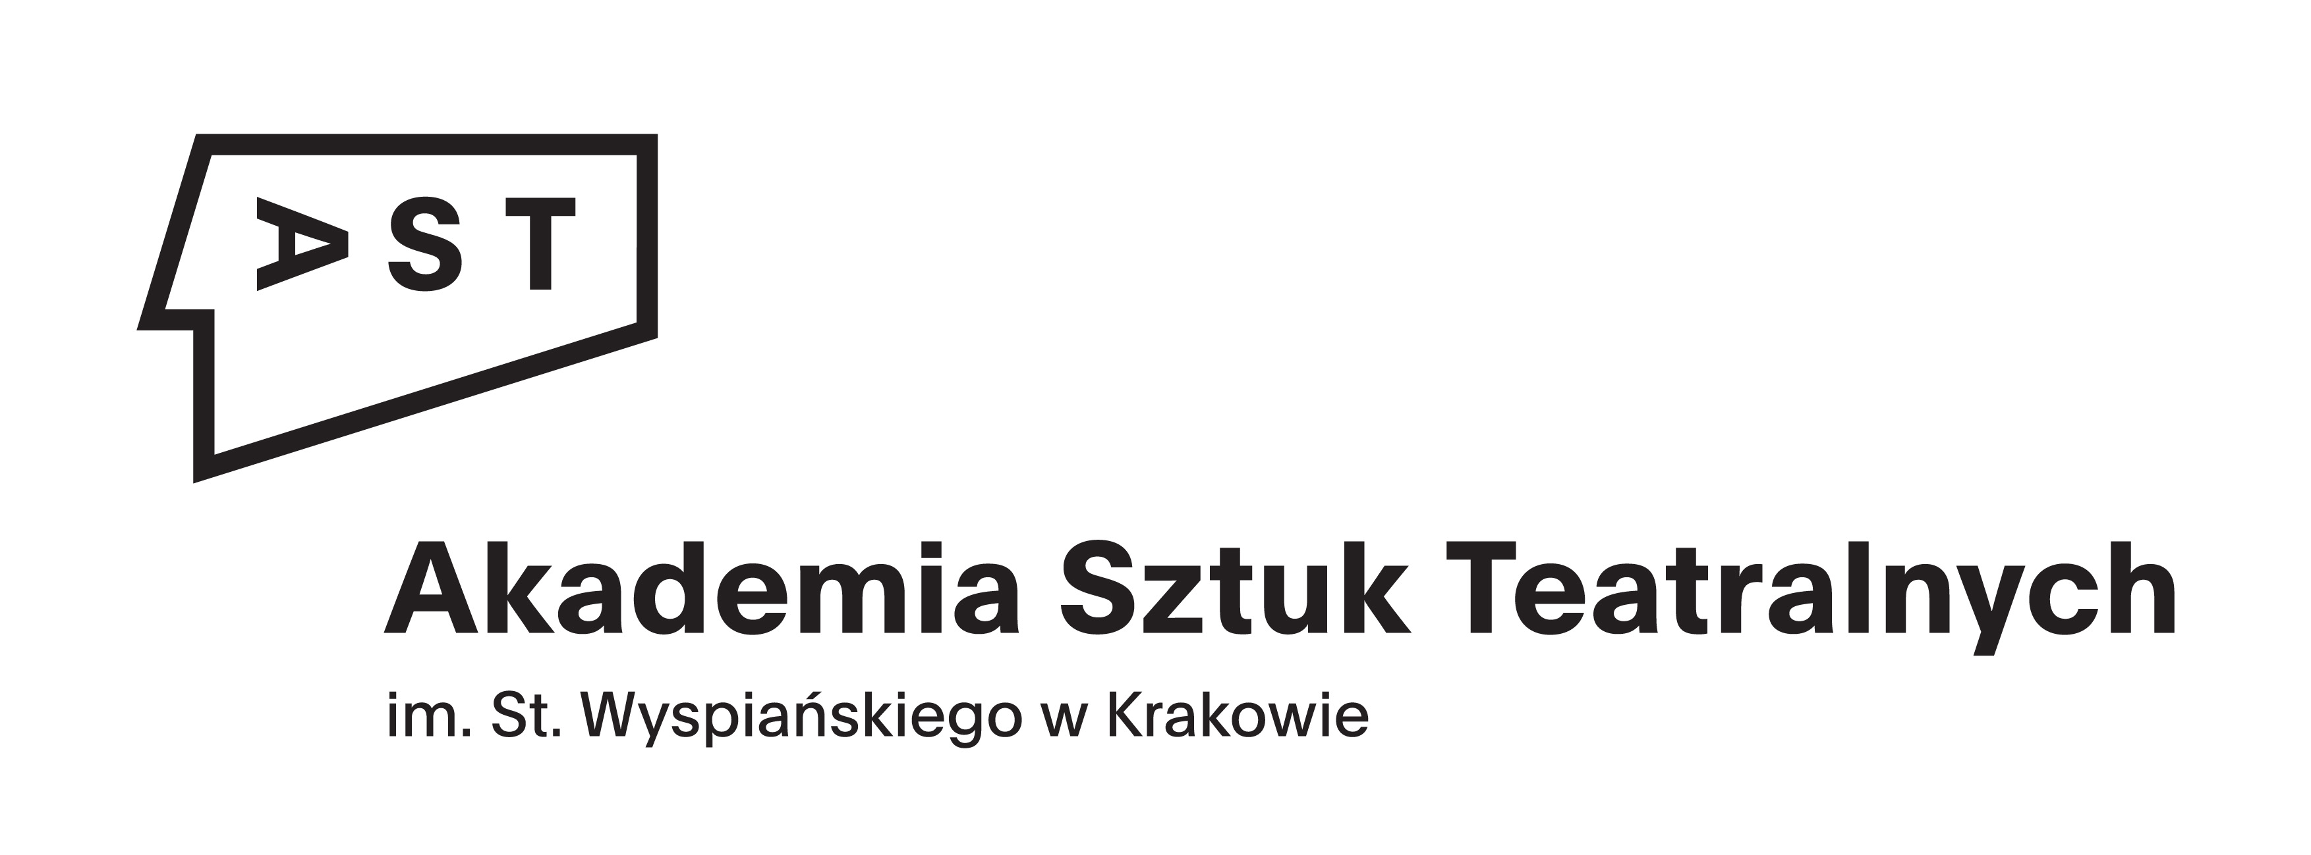 |   Photo
SMS - Student Mobility for Study

AST NATIONAL ACADEMY OF THEATRE ARTS IN KRAKOW
PL KRAKOW11

APPLICATION DEADLINE:
First term / Second term: 15th May

To be filled in CAPITAL LETTERS using black ink

Family Name | Date of birth

First name(s) | Male/Female

Address | Postal code and town | Country

Telephone | E-mail |  | Nationality

Native language | Other languages
Level of Polish language (minimum level required B1)

Home institution

Address

Contact person at home institution | Telephone/Fax | E-mail

Suggested department of studies at AST National Academy of Theatre Arts in Krakow

(mark with an X the department you apply for)

Faculty of Acting in Krakow Faculty of Acting in Wroclaw Faculty of Dance Theatre in Bytom
Faculty of Drama Directing in Krakow Faculty of Puppetry in Wroclaw

Suggested period of studies: First term Second term

Date | Signature

